Name : Sundara Moorthy
Reg No : 192324228
Course code : Cloud Computing And Big Data Analysis
Exp No : EXPERIMENT 13
Date : 23/12/2025

13. Creation of a Virtual Machine using VMware Workstation
Aim
To create and configure a Virtual Machine with 1 CPU, 2 GB RAM, and 15 GB storage disk using a Type-2 Hypervisor (VMware Workstation).
Steps
- Launch VMware Workstation on the host system.
- Click Create a New Virtual Machine.
- Select Typical (Recommended) and click Next.
- Choose Installer disc image file (ISO) and browse the guest OS ISO file.
- Select the appropriate Guest Operating System and version.
- Enter the Virtual Machine name and select the storage location.
- Set Maximum disk size = 15 GB.
- Choose Store virtual disk as a single file.
- Click Customize Hardware:
  - Processor: 1 CPU
  - Memory: 2 GB RAM
- Click Finish.
- Power ON the virtual machine and begin OS installation.
Output
• Virtual Machine successfully created.
• CPU, RAM, and storage allocated as per configuration.
• Guest Operating System installation screen displayed.
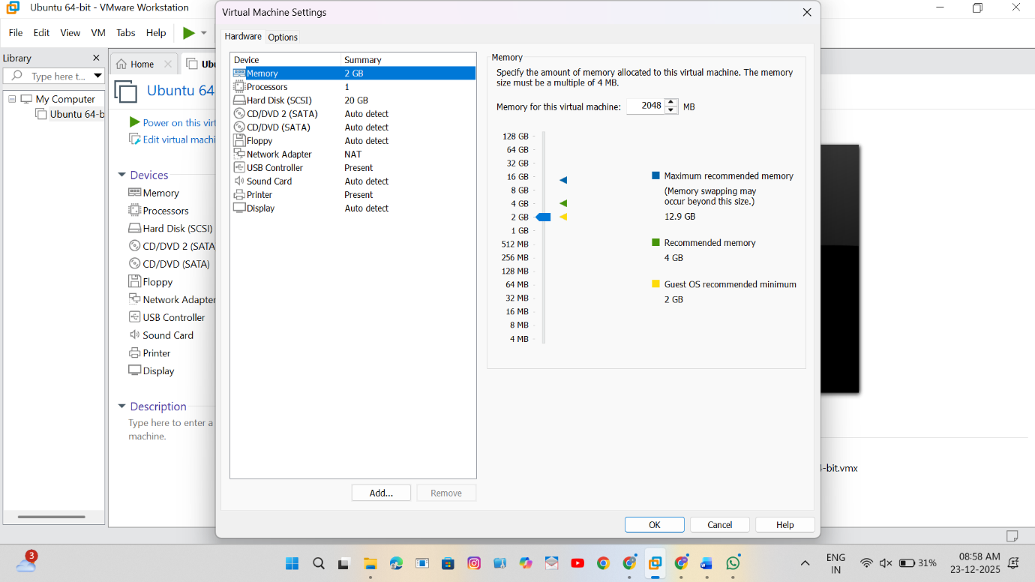

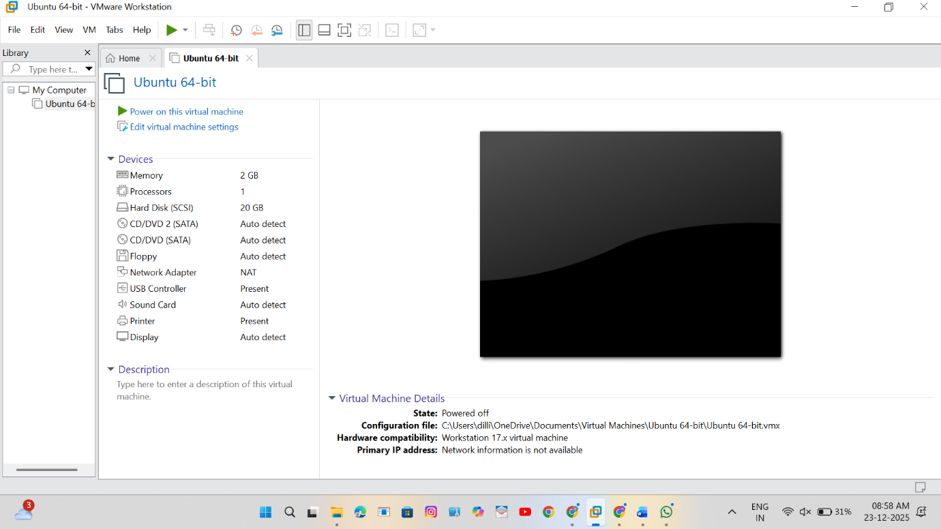
Result
Thus, a Virtual Machine with 1 CPU, 2 GB RAM, and 15 GB storage was successfully created using VMware Workstation.

